|  |  |
| --- | --- |
|  | 2nd Year /Semester4 (2023-2024) |

**Introduction to Artificial intelligence**

**Tutorial Sheet 1**

1. Define using your own words:  
   (a) intelligence  
   (b) artificial intelligence  
   (c) agent  
   (d) rationality  
   (e) logical reasoning
2. Are reflex actions (such as flinching from a hot stove) rational? Are they intelligent?
3. The Turing Test[1] is a deceptively simple method of determining whether a machine can demonstrate human intelligence: If a machine can engage in a conversation with a human without being detected as a machine, it has demonstrated human intelligence. The test is conducted in an interrogation room run by a judge. The test subjects, a person and a computer program, are hidden from view. The judge has a conversation with both parties and attempts to identify which is the human and which is the computer, based on the quality of their conversation. Turing concludes that if the judge can't tell the difference, the computer has succeeded in demonstrating human intelligence. That is, it can think. He predicts that, by the year 2000, a computer will have a 30% chance of passing a five-minute Turing Test with an unskilled interrogator. What chance do you think a computer would have today?
4. The neural structure of the sea slug Aplysia has been widely studied because it has only about 20,000 neurons, most of them large and easily manipulated. Assuming that the cycle time for an Aplysia neuron is roughly the same as for a human neuron, how does the computational power, in terms of memory updates per second, compare with the high-end computer (using table 1.3 from the book)?

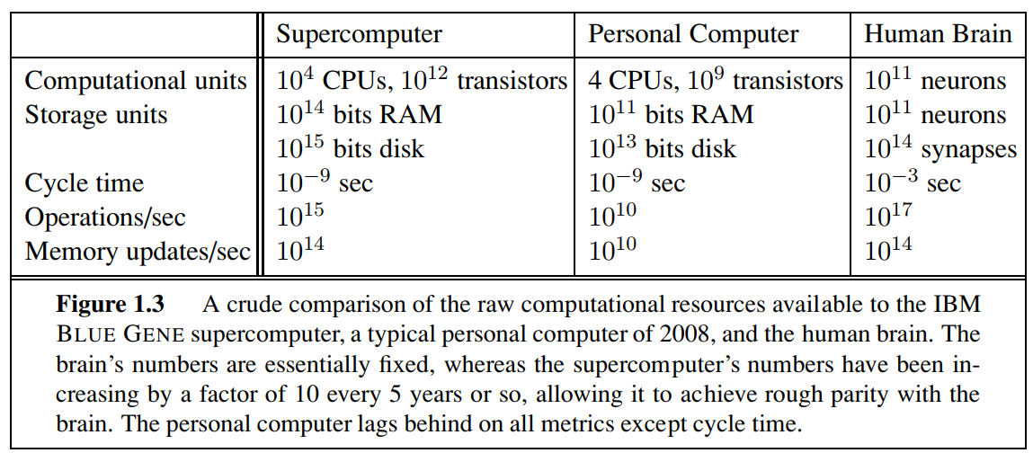

1. To what extent are the following computer systems instances of artificial intelligence?

* Supermarket bar code scanners.
* Web search engines.
* Voice-activated telephone menus.
* Spelling and grammar correction features in word processing programs.
* Internet routing algorithms that respond dynamically to the state of the network.

1. Is AI a science, or is it engineering? Or neither or both? Explain.
2. “Surely animals cannot be intelligent—they can do only what their genes tell them.” Is the latter statement true, and does it imply the former?
3. “Surely animals, humans, and computers cannot be intelligent—they can do only what their constituent atoms are told to do by the laws of physics.” Is the latter statement true, and does it imply the former?
4. There are well-known classes of problems that are intractably difficult for computers, and other classes that are provably undecidable. Does this mean that AI is impossible?
5. Why would evolution tend to result in systems that act rationally? What goals are such  
   systems designed to achieve?
6. Examine the AI literature to discover whether the following tasks can currently be solved by computers:
7. Playing a decent game of table tennis (Ping-Pong).
8. Driving in the center of Algiers, Algeria.
9. Driving in San Francisco, California.
10. Buying a week’s worth of groceries at the market.
11. Buying a week’s worth of groceries on the Web.
12. Discovering and proving new mathematical theorems.
13. Writing an intentionally funny story.
14. Translating spoken English into spoken French in real time.
15. Performing a complex surgical operation.

1. Read Turing’s original paper on AI (Turing, 1950): https://academic.oup.com/mind/article/LIX/236/433/986238